

**AMERICAN INTERNATIONAL UNIVERSITY–BANGLADESH (AIUB)**

**FACULTY OF SCIENCE & TECHNOLOGY**

**INTERNSHIP AFFILIATIONREPORT ON**

***IT & Banking Consultant***

An Internship Report Presented to the

OFFICE OF PLACEMENT and

DEPARTMENT OF COMPUTER SCIENCE

In Partial Fulfillment of the Requirements for the Degree

***Bachelor of Science in Computer Science and Engineering***

**Supervised By**

**Moahimen-Bin-Noor**

**Assistant Professor**

**Submitted By**

**Farhana Yeasmin Munmun , 20-42710-1**

Fall 23-24

Date of Submission: **January 9, 2023**

# LETTER OF SUBMITTAL

January 9th, 2024

**Moahimen-Bin-Noor**

Assistant Professor & Special Assistant

Department of Computer Science

Faculty of Science and Technology

American International University–Bangladesh

**Subject:** Submission of Internship Affiliation Report on IT & Banking Consultant

Dear Sir,

I am writing to submit my internship report for the vacant position of **IT & Banking Consultant** at **Southeast Bank PLC** from September 10, 2023 to December 3, 2023.

During my internship, I was in charge of a number of activities, including aiding Southeast Bank PLC personnel. I have done little all-around work in the bank. I worked in the general banking department making files, creating accounts, verifying Clint's information, and computer difficulties are all examples of tasks. Foreign Trade and Credit are the other two departments of banking. In these two departments, I did there making LC files, organizing all confidential files carefully, knew about how the Credit department works, etc. During the term of my internship, I learned a lot, and I am convinced that I can contribute considerably to any IT or Banking platform. I also had a few difficulties over the term, which I was able to overcome with the assistance of my supervisor. So, I am quite grateful to my supervisor, **Md. Musfiqur Rahman**, Vice President and Manager Operations, SEBL Dhanmondi Branch. Learning how to deal with complex difficulties was so challenging but I overcame all of them and learned a lot. Hope that will help my future personal and professional life too.

In the end, I am thankful to you for giving your time.

Yours Sincerely,



Farhana Yeasmin Munmun

Id: 20-42710-1

Bachelor of Science in Computer Science and Engineering

**LETTER OF ENDORSEMENT**

The Internship Affiliation Report entitled “*Your Report Title*”, has been submitted to the Office of Placement and Department of Computer Science in partial fulfillment of the requirements for the degree of **Bachelor of Science in Computer Science and Engineering** by **Farhana Yeasmin Munmun, 20-42710-1**. This report is presented to the Internship Defense Committee for evaluation and has been accepted.

|  |  |  |
| --- | --- | --- |
|  |  |  |
| Mohaimen-Bin-Noor  *Internship Supervisor* (academic)  Assistant Professor & Special Assistant  Department of Computer Science |  | Victor Stany Rozario  External  Assistant Professor & Special Assistant  Department of Computer Science |
|  |  |  |
| **Md. Musfiqur Rahman**  *Internship Supervisor* (industry)  Vice President and Manager Operations  SEBL Dhanmondi Branch |  | Director  *Faculty of Science & Technology* |
|  |  |  |

**ACKNOWLEDGEMENT**

First and foremost, I want to thank **Allah** for his graciousness in making it possible me to complete my internship report on time.

I would want to convey heartfelt thanks to my **family and friends** for their love and support. Even when things were bad, they were always there for me. I consider myself truly fortunate to have them in my life. I am also grateful to the **Faculty of Science & Technology** for providing me with the opportunity to complete all the subjects special thanks to **American International University-Bangladesh** for guiding me in being able to do so.

I am proud and grateful that I was always held under supervisor **Moahimen-Bin-Noor**, Assistant Professor & Special Assistant, Department of Computer Science Faculty of Science and Technology, AIUB. My internship experience is enhanced by ongoing updates with professional assistance.

I am grateful for being able to have finished my internship at **Southeast Bank PLC** in the IT and Banking fields, where I learned numerous things about the bank. My supervisor, **Md. Musfiqur Rahman**, Vice President and Manager of Operations at SEBL, has taught me a lot and been consistently supportive.

I would also like to convey sincere appreciation to the **SEBL employees** for all of their aid and encouragement. Without it, I would not have been able to complete this internship satisfactorily. They taught me a lot about the banking sector. This experience, I am swayed will be advantageous in my future career.

At the end of my acknowledgment, I want to express my gratitude to the Almighty **ALLAH**  for helping to bless and mentoring me in all my initiatives.

**TABLE OF CONTENTS**

|  |  |
| --- | --- |
| **TOPICS** | ***Page no*.** |
| 1. **Title Page** | 1 |
| 1. **Letter of Submittal** | 2 |
| 1. **Letter of Endorsement** | 3 |
| 1. **Acknowledgement** | 4 |
| 1. **Table of Content** | 5 |
| 1. **List of Tables &Figures** | 6 |
| 1. **Introduction** | 7 |
| * 1. Rationale | 7 |
| * 1. Background | 8 |
| * 1. Objectives | 11 |
| 1. **Activities** | 12 |
| * 1. Work Load | 12 |
| * 1. Organization Wide | 13 |
| * 1. Other Relevant Activities | 14 |
| 1. **Constraints/Challenges** | 15 |
| * 1. Identified/Observed in the Organization | 16 |
| * 1. Academic Preparation | 17 |
| * 1. Personal/Professional Skills | 18 |
| 1. **Acquired Knowledge** | 19 |
| * 1. Consequences to Organization | 19 |
| * 1. Implications to University’s Internship Program | 20 |
| * 1. Effects on Personal/Professional Skills | 20 |
| 1. **Concluding Statements** | 21 |
| * 1. Summary | 21 |
| * 1. Recommendations/Suggestions for future strategic actions | 21 |
| * + 1. Organization | 21 |
| * + 1. University | 22 |
| * + 1. Personal/Professional | 22 |
| 1. **Recommendation Letters** | 23 |
| 1. **References** | 24 |
| 1. **Appendices** | 25 |

**LIST OF TABLES & FIGURES**

|  |  |
| --- | --- |
| **TITLES** | ***Page no*.** |
| **1.1 figure: student-teacher ratio** | 3 |
|  |  |
|  |  |
|  |  |
|  |  |
|  |  |
|  |  |
|  |  |
|  |  |
|  |  |
|  |  |
|  |  |
|  |  |
|  |  |
|  |  |
|  |  |
|  |  |
|  |  |
|  |  |
|  |  |
|  |  |
|  |  |
|  |  |
|  |  |
|  |  |
|  |  |
|  |  |
|  |  |
|  |  |
|  |  |

1. **INTRODUCTION**

Internships give students hands-on experience in a variety of professions, which helps them advance in their careers. Internship knowledge can help influence one's job path and increase one's alternatives. They also allow people to hone their abilities. Employee happiness is enhanced by a pleasant working environment. Students at American International University-Bangladesh (AIUB) have the opportunity to participate in internships as part of their bachelor's degree. Interning at Southeast Bank Limited as an AIUB student exceeded expectations and was a memorable experience.

* 1. **Rationale**

This report is being written to document my internship experience at Southeast Bank PLC. An internship allows a student to get practical experience in the field of their choosing before beginning their future careers as permanent personnel of the company. It's a chance to enhance one's career, network with industry experts, and boost a company or foundation. I was allocated to all banking departments at the SEBL to collaborate on a range of tasks. I am inspired to write my report because I believe it's important to reflect on the information and skills that I acquired and to document my internship experience. This report will also help me recognize my areas of weakness and establish a plan for my future professional life. It has a dual meaning. It will first provide me with helpful documentation of my internship experience. I will find it useful to refer to this record as my career grows. Second, I'll be able to share my expertise with others. This report might be helpful for me and others for gathering knowledge of a company and internship too. So, I would like to share my experience throw a document.

* 1. **Background**

Southeast Bank PLC was established in 1995 with a dream and a vision to become a pioneer banking institution in the country and contribute significantly to the growth of the national economy.



**Figure:** Southeast Bank PLC logo

The Bank was established by leading business personalities and eminent industrialists of the country with stakes in various segments of the national economy. The incumbent Chairman of the Bank is Mr. Alamgir Kabir, FCA, a professional Chartered Accountant. Southeast Bank is run by a team of efficient professionals. They create and generate an environment of trust and discipline that encourages and motivates everyone in the Bank to work together to achieve the objectives of the Bank. The culture of maintaining a congenial work - environment in the Bank has further enabled the staff members to benchmark themselves better against management expectations.

A commitment to quality and excellence in service is the hallmark of their identity. Southeast Bank takes pride in bringing women into the banking profession in a significant number for gender equality.

Southeast Bank Foundation organized a reception at the Officers’ Club Dhaka on March 09, 2019, for the selected Higher Secondary meritorious students coming from financially challenged families for the disbursement of scholarships. Mr. Alamgir Kabir, FCA, Chairman of Southeast Bank PLC and Southeast Bank Foundation was present on the occasion as the Chief Guest and handed over the scholarship cheques to the students [1].

There are a total of 133 branches of Southeast Bank Limited situated in 34 districts in Bangladesh and a total of 131 ATM booths of Southeast Bank Limited situated in 30 districts in Bangladesh [2].

**Services of the Bank:**

* Conventional Banking
* Islamic Banking
* Loans and Advances
* Deposits
* Monthly Savings Scheme
* Double Benefit Scheme
* Pension Savings Scheme
* Western Union
* MoneyGram
* Ria
* Xpress Money
* Trans-Fast
* Alahalia
* Wall Street
* UAE Xchange
* US Money Express
  1. **Objectives**

The primary purpose of this report is to assist me in completing my bachelor's degree at American International University-Bangladesh (AIUB), which includes a mandatory internship course. I opted to work at Southeast Bank Limited in order to have an improved awareness of how the real world runs. To impart my professional time, understanding of how banks activity, and understanding of how to connect with clients with varying needs. The internship execution process at Southeast Bank includes the following steps:

* To know my capability of maintaining professional activities.
* To understand Southeast Bank Limited's IT division's activities.
* To understand how to work in other divisions except IT.
* To learn how the bank's operating system works.
* To obtain a sense of the various types of difficulties.
* To know how the system team supports other branches.
* **To contribute to my field of study.**

1. **ACTIVITIES**

This chapter discusses the significance of developing an activity plan for interns with the objective of effectively finishing the internship program. The efficiency with which an educator assigns tasks is determined by their experience and field progress, whilst interns obtain insight into organizational processes and professional performance.

* 1. **Work-Related:**

I worked at Southeast Bank PLC's Dhanmondi branch in oversaw all aspects of the banking department. There are several activities in the IT and other departments. I worked in the IT System team and enjoyed working at the bank, where I acquired a lot of new concepts. My working hours were from 10 a.m. to 5 p.m. Time management is critical for employees in all divisions of banking, including mine as an intern. The most important aspect of being an intern is how you use your time. Is it possible for me to work while maintaining my professional and personal schedules? I had to leave at 9 a.m. because I had to go to work on time. I am a student as well as an intern. So, I had to maintain my timing very carefully. Because the circumstances were not always right, I tried to keep myself in everything and do what was assigned as perfectly as possible. On the other side, the workplace environment was fantastic. It had an atmosphere of professionalism.

* 1. **Organization-wide:**

**IT department:**

The first time I was exposed to XDR (Extended Detection and Response) technology as an engineer on the IT System team, It left me completely pleased with its capacity to improve corporate security through the aggregation of data from many sources. XDR is a strong tool for security teams, tackling a wide range of cyber threats such as network detections, lateral movement, unusual connections, beacons, exfiltration, and harmful artifacts.

XDR's powerful data-collecting technique and seamless integration stand out, allowing for quick and efficient responses to recognized threats. The capacity of the system to monitor and gather data across several security levels greatly reduces high-priority alarms. This reduction in false positives enables security teams to focus on serious threats, enabling proactive measures to avoid more harm or damage to systems.

XDR's innovations in technology not only increase the threat detection process but also enable security professionals to respond faster and more effectively. XDR gives an overall view of potential risks by integrating information from several sources, assisting in a more educated and focused approach to cybersecurity. This experience on the IT System team has underlined the critical role that cutting-edge technologies such as XDR play in strengthening corporate security and proactively reducing cyber threats.

**General Bank department:**

Working at the General Banking Department, Southeast Bank PLC's frontline customer service center, provided me with a thorough grasp of the core banking procedures that serve as the starting point for all client contacts. This sector, often known as retail banking, is critical in creating and sustaining client connections. My duties included creating new accounts, arranging money transfers, honoring checks, receiving deposits, issuing bank drafts and pay orders, distributing checkbooks, and supplying banking cards.

The periodic trips to other groups to create and strengthen banking connections were a remarkable element of my experience. This proactive participation indicated the bank's dedication to cultivating relationships with a varied clientele, highlighting the importance of relationship-building. The discovery of the plethora of information contained on a check page was perhaps one of the most fascinating elements of my employment in the General Banking Department. During my everyday activities, I became aware of the fine nuances, security features, and other factors involved in check processing. This practical expertise was essential in offering insights into the careful systems that protect both the bank and its clients in financial transactions.

The exposure to the complexities of retail banking emphasized the need to pay attention to detail. Many parts of this department may go overlooked by people who do not work in it directly. During my tenure there, I realized the importance of each transaction, the accuracy necessary to keep correct records, and the importance of adhering to established rules.

In essence, the General Banking Department has been an excellent atmosphere for learning, providing practical insights into the essential banking processes that serve as the backbone of client care. The experience not only improved my understanding of retail banking but also underlined the vital role that this department plays in providing consumers with efficient and dependable financial services.

**Foreign Trade Department:**

During my brief experience with Southeast Bank PLC's foreign trade banking department, I received excellent insight into the intricate procedures and financial instruments used to handle the inherent risks in international trade. The major goal was to secure fast payment to exporters while easing the supply of goods and services to importers. This dynamic area needs not just accuracy but also a thorough comprehension of global trade dynamics.

Southeast Bank PLC maintains a strategic emphasis on long-term customer requirements as part of its ambition to be a renowned investment bank. The bank's purpose is to give clients. This strategy assures a client-centric focus that coincides with the bank's broader objective while operating under the highest ethical standards. The job's confidentiality was one of the most noticeable aspects throughout my brief stay. The foreign trade finance section handles sensitive information pertaining to export and import operations. Handling files needed great attention, and I learned to negotiate the complexities of job completion gradually. The emphasis on secrecy emphasizes the necessity of retaining the clients' and the institution's confidence and integrity.

Furthermore, my exposure to this department's export and import activities underscored the essential role it plays in enabling worldwide trade transactions. impartial, trustworthy, and unbiased assistance to help them achieve their financial goals. Although it might be difficult at times, thorough file handling is vital for guaranteeing the smooth execution of client service cycles. Each piece of paper represents the attention to detail necessary to preserve the bank's commitment to excellence in service delivery.

In the end, my brief experience in the foreign trade finance department of Southeast Bank PLC not only demonstrated the complexities of international trade but also stressed the need for secrecy and precision in financial transaction execution. This experience has helped me grasp the vital role that banks play in facilitating global commerce, as well as the precise processes involved in guaranteeing the success of these transactions.

**Credit Department:**

During my time as an intern at Southeast Bank Limited, I witnessed the credit department's progress, however, the rate of growth fluctuated over the year. It became clear that the bank's diversification of loans in diverse areas was a strategic factor. This finding is consistent with industry best practices for risk mitigation and maintaining a well-balanced credit portfolio.

One important factor that was underlined was the significance of adopting proactive actions to control and reduce the proportion of poor loans, loss loans, and problematic loans. The emphasis on meticulous loan source identification emphasized the bank's dedication to reducing possible risks connected with non-performing assets. The bank wanted to strategically reduce the percentage of poor and lost loans by identifying and analyzing the origins of credit-related difficulties, adding to the overall health of its credit portfolio.

My tasks at the credit department involved actively engaging in the assessment and review processes, as well as learning about the precise procedures in place to detect possible hazards linked with loans. This experience not only improved my grasp of credit management, but it also emphasized the significance of careful analysis and risk mitigation techniques.

Southeast Bank Limited's credit management strategy demonstrates a responsible and forward-thinking approach that recognizes the need for diversification and risk reduction. My participation in this fast-paced environment gave me invaluable perspectives into the difficulties of credit operations and the strategic considerations involved in keeping a strong credit portfolio.

* 1. **Other relevant activities:**

My position as an IT and Banking Consultant intern stretched much beyond technical responsibilities to include a wide range of functions. I performed a critical part in troubleshooting and support operations, guaranteeing flawless functionality for our clients by actively engaging in client contacts. My thorough documentation focus includes meticulously capturing client requests and solutions, as well as contributing to the design of user manuals and instructions. Taking the lead in client training sessions for new system deployments demonstrated my dedication to knowledge transfer. Furthermore, I actively participated in project management activities ranging from planning to resource allocation. I contributed to market research, quality assurance processes, and collaboration across functional areas while maintaining strong relationships with customers. These initiatives provided me with an in-depth understanding of the consulting sector, allowing me to contribute successfully to both the technology and business sides of projects. Continuous learning and proactive problem-solving were essential components of my internship, which helped me establish myself as a flexible and well-rounded IT and Banking Consultant.

1. **CONSTRAINTS/CHALLENGES**

During my internship, I faced a variety of challenges, such as technical issues, communication barriers, client expectations, project timelines, resource allocation, training effectiveness, quality assurance, cross-functional collaboration, client relationship management, and adjusting to new technologies. I overcame barriers in system setups and optimized performance while resolving requirements interpretations and client expectations. Through ongoing communication and expectation-setting activities, I also learned to manage and align expectations. I also increased the efficiency of resource allocation, training effectiveness, and quality assurance processes. Through proactive communication tactics, cross-functional collaboration was improved, and client relationship management was reinforced. Despite these obstacles, they gave possibilities for advancement and contributed to overall organizational progress.

* 1. **Identified/Observed in the Organization:**

I noticed the culture, values, and operational excellence of the organization. A collaborative working environment, operational efficiency, an emphasis on training and development, adaptability to technological advances, employee well-being initiatives, a client-centric approach, a structured onboarding process, strict adherence to industry regulations, effective communication channels, and a commitment to diversity and inclusion were among the key observations. Cross-departmental collaboration was fostered, procedures were simplified, and open communication was promoted. It also exhibited flexibility in implementing new technology to enhance procedures and provide novel solutions. The author is committed to project-related responsibilities at work, emphasizing a good environment and supporting coworkers. They've earned tremendous information and experience, especially in terms of recognizing the fundamental operating system. Their group work and support have given them more confidence in handling problems. Policies and activities have demonstrated the organization's commitment to diversity and inclusion. These observations gave an understanding of the organization's strengths and weaknesses.

* 1. **Academic Preparation:**

My academic preparation provided a solid foundation for solving the issues I experienced during my internship, although I saw a small mismatch between the distributed responsibilities and several organizational operating activities. While my coursework provided me with a strong technical foundation in IT and Banking Consultancy, the industry's dynamic nature exposed the need for a more thorough grasp of cross-functional cooperation, client relationship management, and project planning. Despite this variation, my academic experience was very applicable to this particular job, providing a solid knowledge of technical issues and problem-solving approaches. Moving forward, I acknowledge the significance of supplementing my academic knowledge with a deeper understanding of wider business operations in order to better match the operational dynamics of the firm and future work requirements. The job market needs continuing expertise in the industry, and educational achievement improves self-confidence and aids in navigating workforce problems. Practical experience is essential for acquiring a thorough grasp of a company. An internship in a respected organization gave me significant knowledge and experience, allowing me identification of problems and obstacles. This experience has highlighted the importance of ongoing study and the integration of academic ideas to actual-life situations for enhanced professional development.

* 1. **Personal/Professional Skills:**

I explored and strengthened both personal and professional skills all through my internship at Southeast Bank PLC. While some were well-suited to the task, there was room for growth. I am devoted to continual professional development in order to fulfill the needs of the industry and future organizational requirements. Real-world challenges and interactions with students and teachers aided in the development of experience, confidence, and self-evaluation. This self-evaluation directs my efforts toward skill development in order to build a more comprehensive professional profile. Some are given below:

* Expertise in collaborative cooperation and the ability to work smoothly with different teams.
* Current awareness of, and alignment with, the aims of our employers.
* Excellent problem-solving abilities.
* Understanding the significance of client care.
* Outstanding communication skills.
* Excellent organizational skills and the ability to handle assignments efficiently.
* Capable of professional communication.
* Competence in collaborative work and the capacity to deal with diverse teams.
* The capacity to adapt to changing work circumstances.
* An attitude of continuous learning.
* A proactive and self-motivated attitude.
* Computer literacy and competency.
* Making ethical decisions.
* Ability to adapt to new technology or processes.
* The ability to achieve success under duress.
* Excellent time management capabilities

**Some lack of knowledge:**

* Improve technical abilities through cross-functional collaboration.
* Enhance project management skills by focusing on planning, resource allocation, and timetable adherence.
* Increase client relationship management and commercial operations acumen, resulting in a better understanding of ever fluctuating client expectations and client satisfaction.

1. **ACQUIRED KNOWLEDGE**

My internship with Southeast Bank PLC was a rewarding learning experience that provided me with a variety of relevant lessons, information, skills, and best practices. First and foremost, I developed a better knowledge of cross-functional teamwork after witnessing its critical role in the overall success of the project. Project management experience has sharpened my abilities in effective planning, resource allocation, and timetable adherence, resulting in a more structured and efficient approach. Furthermore, the emphasis on customer relationship management has raised awareness of changing expectations, creating a client-centric culture. This internship not only improved my technical abilities, but also reinforced in me the importance of continual learning and adaptation in the ever-changing banking and IT industry. These fresh concepts as well as strategies will undoubtedly influence my professional path, establishing the foundation for future activities.

* 1. **Consequences to Organization**

Southeast Bank PLC internship has had a tremendous influence on the company by offering new perspectives and prospective changes. The internship gave me insights into operational efficiency, client relations, and project management, which resulted in increased cross-functional dynamics and project outcomes. The experiences also revealed operational issues, allowing the business to address and improve internal procedures for increased performance. The internship provided a chance to immerse oneself in a communication atmosphere ideal for future pursuits, which was a beneficial experience in terms of knowledge and practical exposure. The emphasis was on developing the skill of learning by drawing on experiences and applying information in current and continuing education. By offering a suitable communication atmosphere, the three-month program is intended to boost my professional knowledge and job possibilities. I painstakingly gathered the necessary material and wrote a thorough report. My primary concentration was on studying and implementing what I had learned in both current and previous courses. The internship provided me with significant insights into the key qualities of the industry in which I worked. The internship provided the intern with significant insights into the basic aspects of the industries with which they worked.

* 1. **Implications to University’s Internship Program**

The university internship program has significant implications for students due to the way it overcomes the gap between academic knowledge and practical application. The strength of the curriculum stems from exposing students to a variety of issues while stressing technical skills, relationship-building with clients, and project planning. This fits with changing industry requirements and prepares students for future employment. Internships are now available as a credit option and a required component of the Faculty of Science and Technology's degree program, giving important experience and practical insights into industry-related tasks. The student was able to pick and successfully finish an internship at a selected organization thanks to the help of the Faculty of Science and Information Technology, the AIUB Department of Placement and Alumni, and various other things to consider.

* 1. **Effects on Personal/Professional Skills**

The internship developed my technical skills by delivering hands-on experience in IT and banking consulting. It presented me with project management, working with customers, and cross-functional cooperation, broadening my skill set beyond technical areas. It also identified areas for development, inspiring me to increase my business acumen, negotiating skills, and risk management. My professional identity has been influenced by the internship, which has instilled a dedication to constant learning and adaptability for future career ambitions.

My internship in the IT and Banking department was critical to my professional and personal growth. It enabled me to swiftly learn new skills and adapt to different surroundings as a member of the System Administrator team. Despite my lack of prior knowledge, I actively engaged in duties, promoting efficiency and valuable contributions.As I maintained open channels with coworkers and mentors, offering insights into the complicated workings of a bank, effective communication was critical. This experience bumped into my knowledge base and provided me with practical insights.

The strict daily schedule of 10 a.m. to 5 p.m. pointed out the essence of timeliness and completing deadlines. This internship provided vital knowledge that will affect my future career, particularly in the fast-paced and time-sensitive IT and banking departments.

My self-confidence was also strengthened by the internship, which gave me faith in my abilities to take on greater tasks and achieve ambitious professional ambitions. Learning to be a system administrator provided a good basis for my career development. The confidence put upon interns, particularly in the financial industry, was exceptional. I was given significant work and was actively involved in a project created by the system team, demonstrating their trust in my talents.

The internship in the IT and banking departments was revolutionary in nature, improving communication, skill acquisition, and industry public consciousness. It has increased my technical knowledge and self-confidence, allowing me to contribute meaningfully to projects. Professional development has been aided by trust, distinctive project participation, and timeliness. The internship provided real insights and skills for a bright future in the energetic IT and banking sector. . This internship was a complete and satisfying learning experience for everyone.

1. **CONCLUDING STATEMENTS**
   1. **Summary**

The internship program was a significant event, presenting important knowledge into the operational dynamics of an organization of professionals as well as the agility necessary to negotiate regular changes. This experience has sharpened my perception, perseverance in conquering technological problems, and logical thinking, instilling in me a sense of cautious and confident work.

A vital component of the internship has been its major help in improving my team teamwork abilities. Working effectively in a team necessitates not just cooperation but also respect for other ideas and opinions, both of which are critical for organizational success. Participating in group talks, particularly brainstorming sessions, allowed me to discover and address difficulties that would have been difficult to address on my own as well.

Recognizing the worth of compassion in the workplace is critical. While adapting to the professional environment takes time, my dedication to not doing work that defies ethical principles is strong. Contributing successfully to society is a responsibility I take seriously. Furthermore, I am committed to developing an in-depth understanding of all relevant topics surrounding my internship.

In conclusion, my internship in the IT and banking sectors was critical to my skill development, communication improvement, and industry insights. Working with the System Administrator team demonstrated agility and efficiency, while excellent communication enhanced professional connections and expanded my understanding of banking processes.

The experience considerably increased my self-esteem, confirming my ability to bear tasks and contribute effectively to the organization. The experience improved my self-confidence dramatically, confirming my ability to handle tasks and contribute effectively to initiatives. The organization's dedication towards encouraging growth is seen in the trust put in interns for significant responsibilities. Punctuality and meeting deadlines highlighted the value of time management in the fast-paced IT and banking sector. Overall, this internship has been a significant steppingstone, providing me with the necessary abilities and trust to pursue a successful career in the company's operations.

* 1. **Recommendations/Suggestions for Future Strategic Actions** 
     1. **Organization**

It is recommended that the internship program be enhanced by including a variety of projects and duties that closely mirror current industry trends**.** Implementing a well-organized mentoring scheme would give interns focused advice and assistance, improving their overall learning experience. Implementing a systematic feedback method is critical for encouraging open communication and ensuring that intern experiences contribute positively to ongoing program development. Encourage cross-functional exposure via facilitating contact with diverse disagreements within the organization to widen interns' perspectives. This multimodal approach will not only link the internship program with reality in the market but will also give participants a full and fulfilling experience.

* + 1. **University**

In my experience, the internship program at American International University- Bangladesh (AIUB) seems suitable for students. Having collaborative agreements with industry stakeholders to ensure that the curriculum remains closely connected with modern industry demands is recommended to improve the university's academic offerings. The cooperation will give students a more thorough and practical education, better preparing them for the needs of the workplace. It is also encouraged to organize pre-internship workshops or seminars to provide students with key soft skills, insights into industry expectations, and effective communication methods. These pre-internship courses will prepare students to handle the professional world with increased confidence and competence. Conducting frequent evaluations is critical for gauging and improving the success of the internship program. This entails gathering input from both students and collaborating companies, as well as leading an iterative process that finds areas for improvement and modification. This cycle of perpetual growth guarantees that the internship program stays dynamic and responsive to changing student and industry demands. Furthermore, maintaining alumni networking events is a beneficial tactic. Alumni who have successfully completed internships can share their experiences with current students, providing them with practical insights and important guidance. This project develops a feeling of community and mentorship, resulting in the formation of a supporting network that bridges the gap between academic learning and real-world application. These ideas, taken together, are intended to strengthen the university's commitment to offering an education that effectively merges academic knowledge with practical application in the workplace.

* + 1. **Personal/Professional**

It recommended engaging on a methodical road of continuing professional development to promote both personal and professional progress. This entails creating a detailed strategy to acquire new skills discovered during the internship, with a particular focus on business acumen, negotiating abilities, and risk management. Proactively exploring networking opportunities within the sector, which includes active involvement in events, seminars, and workshops, is critical. This involvement not only broadens professional relationships but also guarantees that one stays up to speed on advances in the field. Pursuing advanced technical training along with necessary certifications is recommended to stay at the forefront of technological improvements in the IT and banking sectors. The commitment to constant learning provides a competitive advantage in a continuously shifting related to technology globally.

Furthermore, establishing a practice of regular self-reflection is essential for personal and professional development. Assessing individual growth, finding areas for improvement, and maintaining a proactive attitude to skill advancement and career development are every component of this. Embracing reflective methods lays the groundwork for a dynamic and adaptive professional path, assuring a continual trajectory of success and progress.

**RECOMMENDATION LETTER**

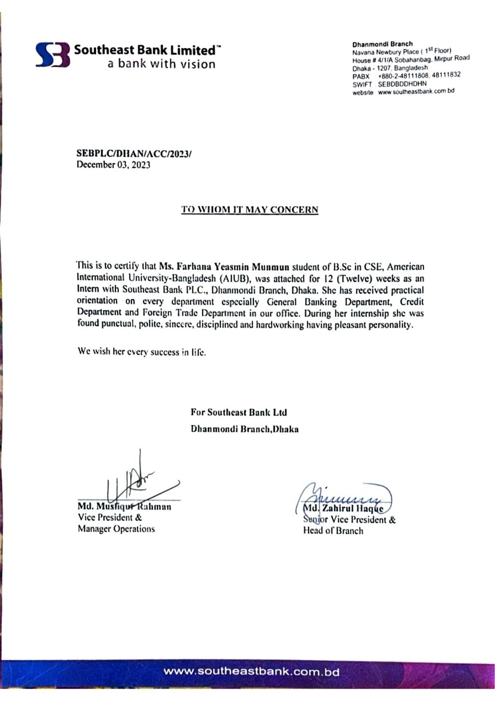**REFERENCES**

**[1]** [**https://www.southeastbank.com.bd**](https://www.southeastbank.com.bd)

**[2]** [**https://www.banksbd.org/sebl**](https://www.banksbd.org/sebl)

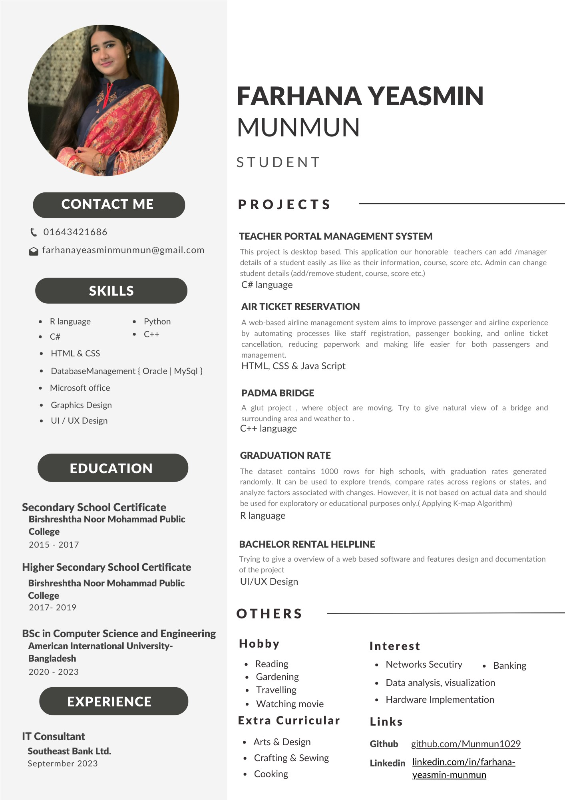**APPENDICES**